University of Engineering and Technology, Lahore
Name: Maria Abbas
Reg No: 2026(S) CYS_61
Department: Computer Engineering
Degree: Cyber security
Section: B
Assignment: PF Lab week 3
Date: 16 March 2026
CLO1

Lab Tasks
While loops:
Task 1
This programme uses a while loop to print star pyramid. The outer loop controls the rows and inner loop controls spaces.
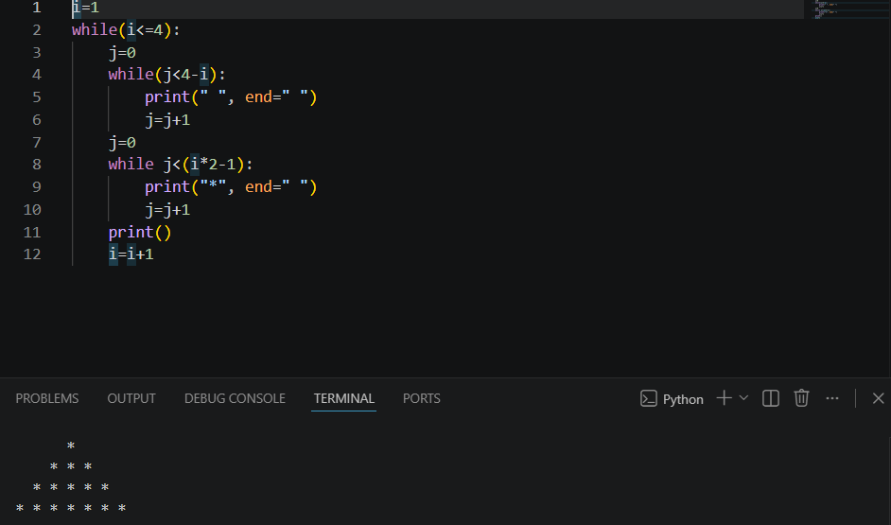
Task 2:
This programme uses a while loop to count and print numbers from 1 to 5. It repeats until a condition become false.
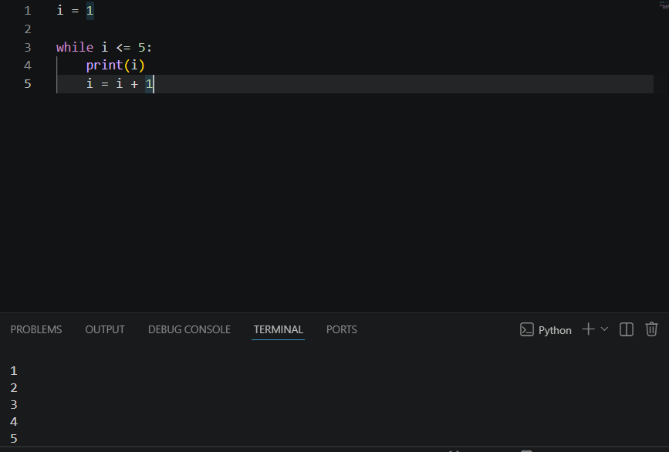
Task 3:
This programme uses a while loop to print the word “Hello” five times on the screen. It repeat a specific task using a counter variable.
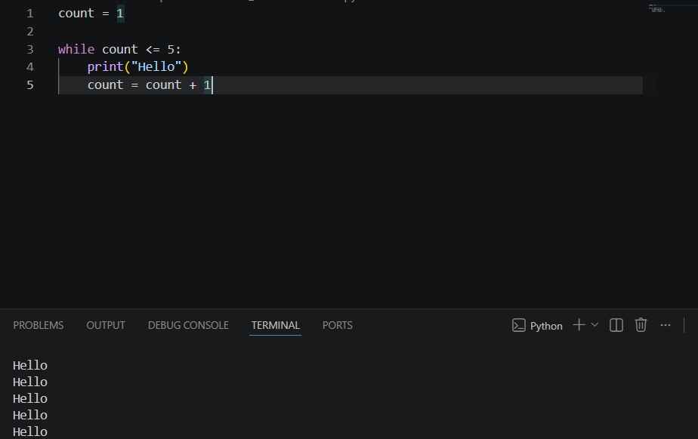

Task 4:
This programme uses a while loop to skip count and print even numbers up to 10.
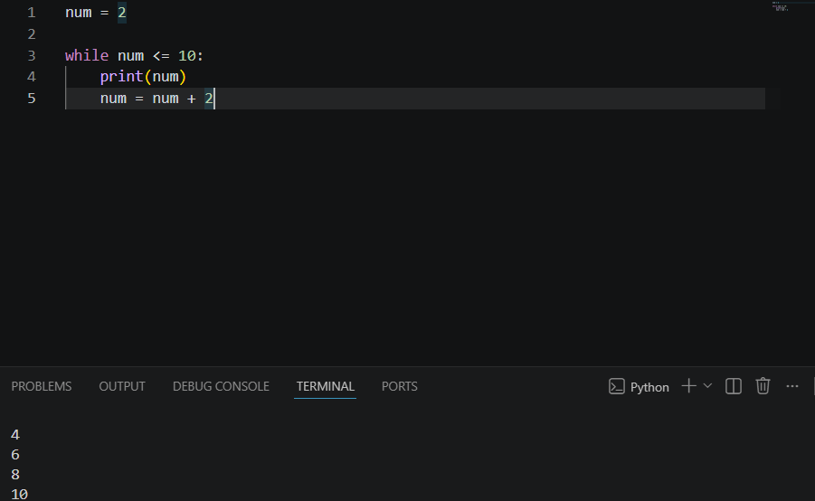
Task 5:
This programme uses a while loop to print a reverse countdown from 5 down to 1.
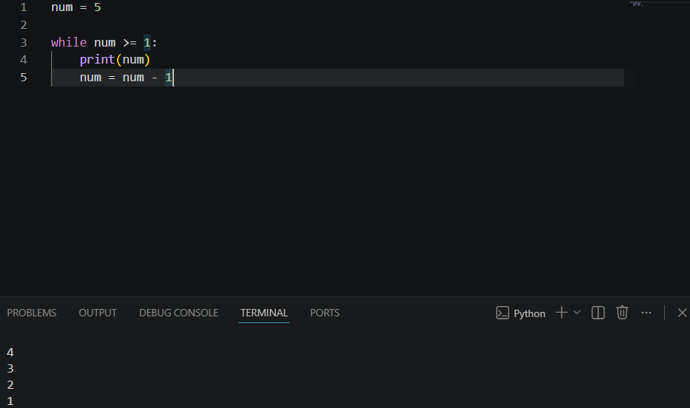

Task 6:
This programme uses a while loop to print a star (*) pattern. It prints 2 stars in the first line, 5 stars in the second line, and 7 stars in the third line.
